**SDEV 325**

**Detecting Software Vulnerabilities**

**Homework 1**

**Ben Brandhorst**

**August 19st 2019**

**Discuss the steps you had to perform to get the source code running within the Cloud9 environment.**

I setup the Cloud9 EC2 instance by following the directions contained in the “Using Cloud9” PDF under the “AWS Cloud Resources” section of the SDEV 325 classroom. Once the Cloud9 instance was setup properly, creating Hello World applications was as simple as selecting:

File < New From Template < Java Console Application

File < New From Template < Python File

File < New From Template < C++ File

Each of these templates provides the basic framework necessary to print a single line of text to the console. I used the existing framework to generate a total of five lines of text for each application.

**You should also provide well-organized and labeled screen shots in a word or PDF file documenting the successful running of each of your Hello, World Applications.**

**Successfully running HelloWorld.Java (JAVA) in the Cloud9 IDE**

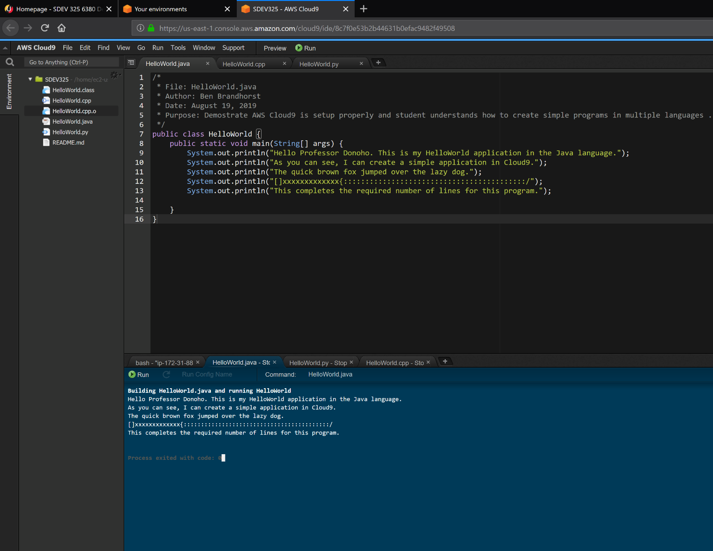

**Successfully running HelloWorld.py (Python) in the Cloud9 IDE**

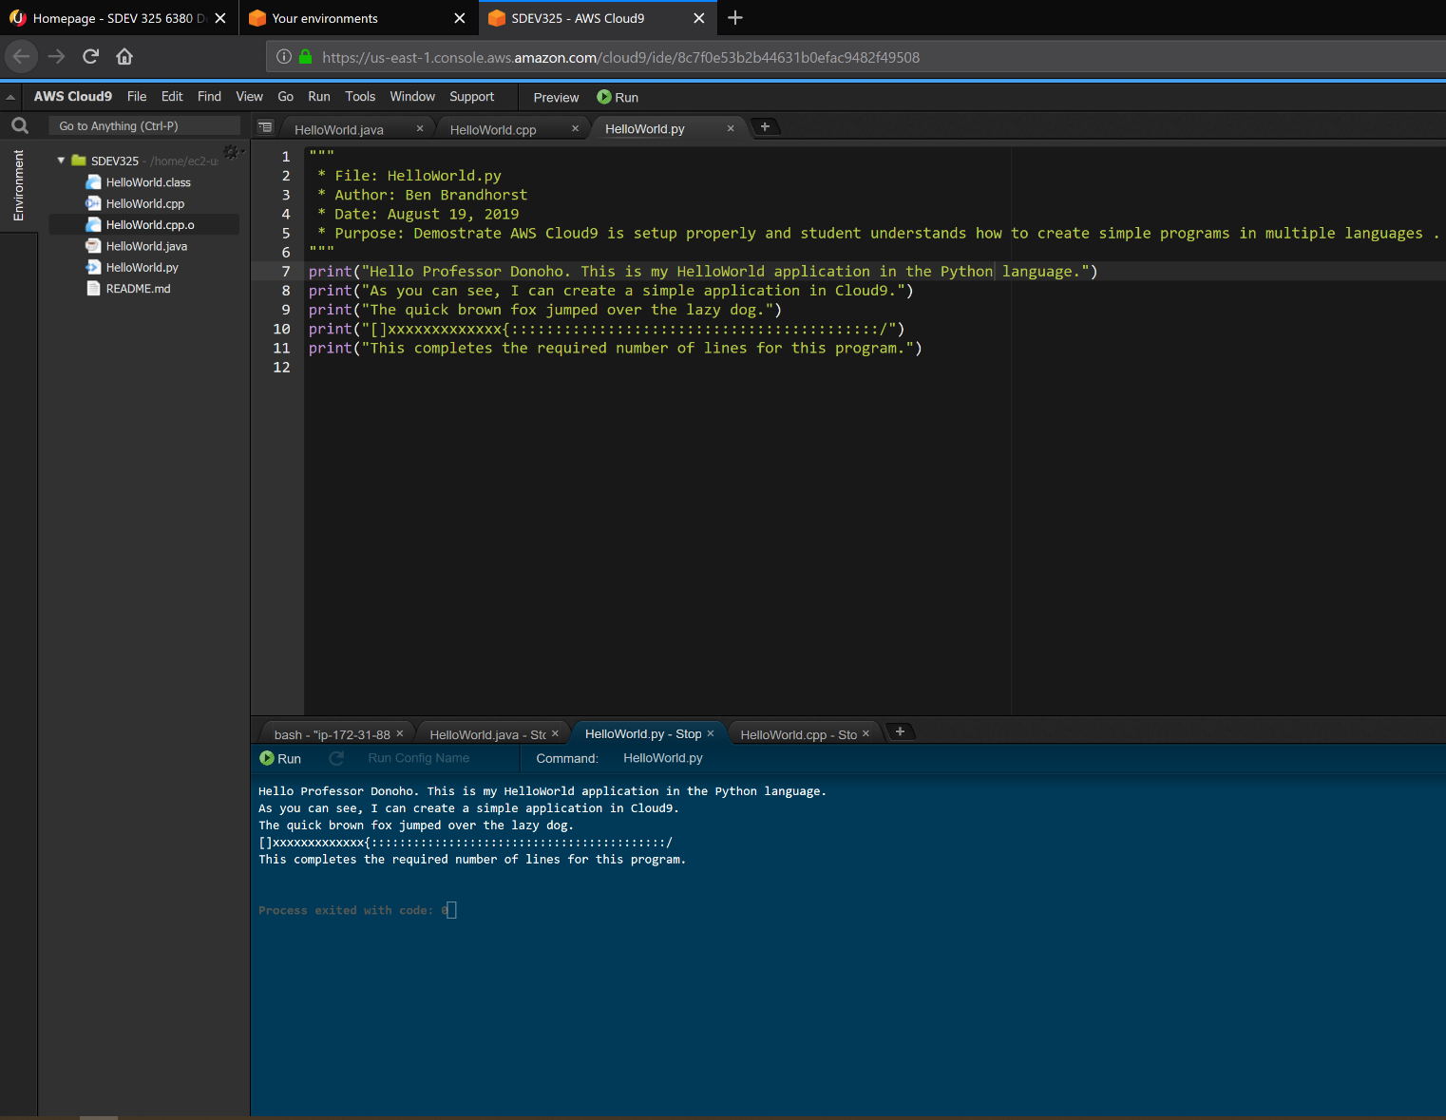

**Successfully running HelloWorld.cpp (C++) in Cloud9 IDE**

